Bachelor thesis proposal
Filling the educational gap with sovereign education
Cooperation support in future education

Problem statement
Children like to follow their imagination and build their own creations, for example robots and electrical circuits. However, they struggle to piece together the necessary steps and actions to take in order to succeed with their plans. Although they’re motivated and curious, it is still hard to do the work all by themselves. Sovereign education is the natural process of developing one’s personality using the innate intrinsic initiative to fully develop the spectrum of individual potential. To support this process in a systematic way, the Cleverle-Navi was created.

The idea is to support kids with a media-rich platform with explanations, vendors and experts. Retired people with a lot of experience can act as the experts. They provide help and education for the kids, in the realization of their idea. The kid and the expert can learn and work together. Ning is seen as a suitable platform. This platform can be customized and enriched with multimedia- and social content from twitter and youtube. E-learning courses should also be included. Once realized, the platform needs to be promoted in order to make people aware of its presence. The requirements are captured in Attachment C – MoSCoW analysis.

Research questions
- How can the platform co-exist with the current education system?
  - Mr. Helmeth has contact with the German ministry of education and research. The minister encourages this idea.
- In which other ways can children be supported in the realization of their ideas?
- Are retired people prepared to become an expert?
- How can the platform users be encouraged to collaborate?
  - User generated content
- What would be the design, contents and required functionality of this platform?
  - Compare competences: gamefication
  - Sharing and collaboration while protecting privacy
  - Graphical view of skills and knowledge gained (e-portfolio)
  - Who or what can grant skills in this e-portfolio?
  - Also see Mr. Helmeths functionality wish list, found in Links
- Which platform is the most suitable for the objective (cooperation support)?
- How can this platform be promoted to its target audience?
- What might be reused from the old website: (Cleverle-NAVI and Cleverle-Atlas)?
- What will be the scope (nationwide, multi-language)?

Relevance
This thesis is relevant for the subject of collaborative systems, e-business, sovereign education and informal education (at home). The architectural design can play a vital role in making the platform co-exist with the existing (formal) education.

Background information
Mr. Wolfgang Helmeth is the founder of this initiative. He calls himself an autodidact – he learns by doing it himself. He taught himself the necessary knowledge and skills, and became an engineer. His theory consists of all areas in life, subdivided in modules and steps. Briefly:
- nature, as the common base of life
- organization, as an instrument to structure life, law, transport politics, commerce…
- technic, as an instrument to make life easier
- culture, as an possibility to make life meaningful
Every individual has its own preferred area(s). His website gives tips/advices for children how to develop these areas. For example: a child is interested in technic and wants to become a pilot. Cleverle-Navi can then advice to learn how to fly a mini-airplane. However, this website (http://cleverle-navi.de/index.php) has become outdated. “Cleverle” refers to people who start with the natural synergetic lifelong self-development process at an early childhood.

Mr. Helmet says that “whenever anything flourish within you, this request should be fulfilled just in time”. “Children have continuously switching interests, yet nothing happens.” When you are wondering what the educational gap exactly is, please see attachment A – The mission statement explained.

The co-existence of both systems
“The idea of learning throughout life has not misled the Commission into overlooking the importance of formal, as against non-formal or informal, education. On the contrary, it believes it is within formal education systems that the skills and aptitudes individuals will need in order to carry on learning are acquired. The role of formal and informal education, far from being in opposition one to the other, is therefore to cross-fertilize each other. For this purpose, however, education systems need to adapt themselves to these new requirements (…)” (Delors, 1996, p. 115)

Overview of the chapters
The thesis can consist of the following contents:
- Introduction
  - Educational gap
  - Filling the gap
  - Status Quo
  - Concept: cleverle-navigator
- Concept for the new cleverle-navigator
  - Future scenario
  - Functional requirements
- Architecture & components of the new cleverle-navigator
  - Platform (e.g. Yammer or Thinkfinity)
  - Promotional/referring website
  - Social media integration (Twitter, Skype)
  - E-learning content integration (udacity, edx, coursera)
  - Integration with suppliers systems
Example: see attachment b – system architecture.

Time Schedule
Generally five to six months. Planning according to your personal preferences.

References
Delors, J. (1996). Learning the treasure within. Paris: United Nations Educational, Scientific and Cultural Organisation.

Links
The Cleverle-Navi :http://cleverle-navi.de/index.php
Denzlinger-Cleverle :http://denzlinger-cleverle.de
Functionality wish list :http://www.edeju.de/projekte/Souveraene%20Bildung/Evolution.htm
Xprize learning prize :http://www.xprize.org/prize-development/learning
Thinkfinity :http://www.thinkfinity.org/community/about-us
Yammer :http://www.yammer.com/
Xing :http://www.xing.com/de
Ning :http://www.ning.com/

Attachment A – The mission statement explained
Why the Cleverle-Navi?
How to prepare our children for their future? As we don’t know what their future will be, let’s try to do our best for them. The best is – I believe – is to enable them to make use of their individual potentials. To make use of their potentials they have to be developed – to gain competences. As every child is different, the process of development must be individual. Give them a start to a lifelong process of self-driven development.

To conform to the permanent evolutional reality, we need an actual overview of our emerging globalizing world.

As every child is born with curiosity, own-initiative, individual meaning, - finally as a sovereign personality, we need a possibility, to allow them to find their own way of development, which starts in the early childhood and accompanies them during their lifetime. The goal is, to provide an educational system that guides you to reach any qualification.

Therefore Cleverle-Navi is made
To make full use of it, you have to make a "driving license". But you can start with a few functions, and when you got confidence, you will wish to use more and more functionality. Try it out - and have fun with it.

But – don’t we already have an educational system which provides all that?
I don’t think so - because I found a multidimensional gap: the education gap in education systems.
The analysis of the classical education system (formal education), and the two areas of non-formal and informal education shows that the systematic promotion of sovereign self-expression is realized by none of the current systems.
The education gap has at least 10 dimensions:
1 No more looking at the entire spectrum of individual potential (hard and soft skills, character)
2 No teaching of fundamentals (each life area has its specific principles)
3 No sensitivity to individual disposition (just in time)
4 No possibility of sovereign education (create free and spontaneous synergistic networks)
5 No promotion of self-development as "creating an individual meaning" (part of the art of living)
6 No certification (e-portfolio) of individual competences
7 No systematic use of the skills of civil society
8 No parole in real life entrepreneurial spirit - self-promotion
9 No chaos fitness ability, etc. example: a shopping mall / center is able to deal with chaos (the clients)
10 Therefore no way to promote individual life art - to become an individual sovereign artist of life
Can that multidimensional gap be closed by changing the educational system, or do we have to think fundamentally different?
There is a fundamentally different approach to education needed in order to close the multidimensional gap. None of the three educational systems (formal, non-formal and informal defined by the UNESCO) focus on the individual process of flourishing on the whole range of individual potential.

Attachment B – System architecture
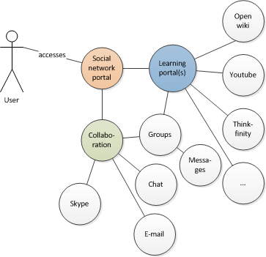
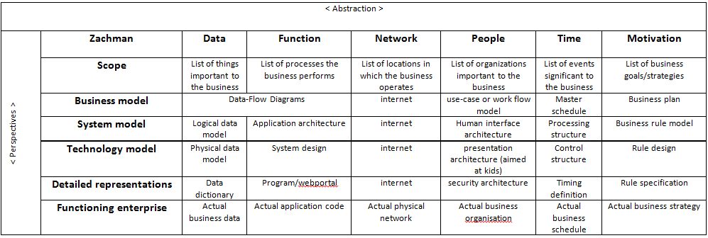

Attachment C – MoSCoW analysis
Date: 17-05-13
Limitations: | time | budget | resources
 | six months, 40 hours per week. | unknown | client, student, volunteer(s)
Must have: | Which functional requirements are essential for this new platform?
- Providing an explanation of the Cleverle way of learning (open wiki)
- Referring to learning content (e.g. thinkfinity, youtube)
- Encouraging to learn and collaborate with experts (local chat, e-mail, skype, …)
Should have: | What has a high priority, but is not essential?
- Tracking individual achievements and learning progress, and peer comparison
- Learning/collaboration groups
- Building an active community targeting six to fourteen year old children
- Experts able and prepared to educate kids
- User interface for kids
Could have: | What could be made when there is enough time and budget available?
- Connection to vendor’s website for direct ordering of materials
- Publishing our own learning content
Would have: | What do you want when time, budget and resources are unlimited?
- Multiple translations and volunteers willing to support across the globe
- Supporting charity

See for more functional requirements (in German): http://www.edeju.de/projekte/Souveraene%20Bildung/Evolution.htm

Contact details
Wolfgang Helmeth Tel.: 07666/602469
Berliner Str. 17 79211 Denzlingen (Ger) Mobil: 01522/8700760
Skype: EDEJU-international E-mail: EDEJU@t-online.de
Tel.: 07666/4575 URL: www.EDEJU.de

Prof. Dr. Achim P. Karduck
Furtwangen University
Faculty of Computer Science
Robert-Gerwig-Platz 1
78120 Furtwangen
Germany
Tel.: +49-7723-920 2429
Fax: +49-7723-920 2610
Email: karduck@fh-furtwangen.de

